Support



Support Us
SUPPORT US
Secondary school girls benefit from our programs and service to empower them to be independent ladies in society. We rely on your contributions to continue our commitment to enriching the lives of the girls we serve. With your support we can reach more girls and work in partnership with more secondary schools
We appreciate the contributions of caring individuals and organizations like you who make it possible for us to mentor, nurture and empower our girls thus impacting them positively
YOUR DONATIONS
We are seeking funds for:
- Support staff
- Production of curriculum resources
- Office space/equipment
- Scholarship funds
Our programs enable girls to make informed decisions that are beneficial to their sustenance, give them economic power to avert poverty and heighten their self-esteem. individuals who would not otherwise have the opportunity or the skills, to participate in a structured socialization, recreation, life, employment skills program to prepare them for further work experiences and successful community living.
Our aim is to enhance the girls learning, provide the skills they need to achieve, and build character that ensure success in life. With your support we can help them develop into independent, responsible, proper ladies of society.
Your donation to OGAV will help enrich and empower the lives of our girls and support them financially through bursary and scholarships each year. We need your help! Please give generously. Thank you for your support!

Volunteer

VOLUNTEER
Ornaments of Grace and virtue’s ability to meet the needs of the girls in our community would be greatly diminished without the support of our loyal and hard-working volunteers. Our volunteers make an important contribution to those we serve.
There are a number of different opportunities for volunteers:
- mentoring
- assisting in the delivery of programs – Facilitator
- fundraising
- providing general administrative support
- committee work and special event support
We value our relationship with volunteers and want it to be mutually beneficial. Volunteering at our partner schools will help you to learn new skills, make new connections and impact our girls in a significant way.
As part of the volunteer screening process, OGAV conducts interviews with all potential volunteers and provides an orientation for new volunteers –“train the trainers”. We will check references on all volunteers. Special forms will be provided to you in order to complete this screening process.
We are always looking for volunteers to fill different positions. If you are interested in volunteering, please send your resume to contact@ogav.org.
OGAV welcomes Volunteers from all communities.

What we do
OGAV WHAT WE DO
We are passionate about nurturing, empowering and mentoring girls. So we teach, encourage and mentor them to :
ASPIRE
Dreams drive each of us. Whether you want to be a doctor, teacher, or an artist your ambition can become a reality with the right mind set.
WE EMPOWER
We empower students with the tools and virtues to excel. We offer six initiatives – Career Guidance, Skill development, Academic skills, Character education, Life coaching and Leadership development for a three year mentoring and nurturing program. These are holistic approach that is impactful to empower the girls and change the culture of their school by making a difference.
ACHIEVE
OGAV runs a student centered focus groups (club). We are a community building people that is preparing a community of girls within the school for successful career and life who can in turn change the community positively.

Who we are
Ornament of Grace and Virtue is a Christian Non-Government Organization (NGO). It is an organization that is passionate about nurturing, mentoring and empowering girls to be independent young women in society. Ornaments of Grace and Virtue (OGAV) is not affiliated with any religious denominations.
It was founded and registered with the Federal government of Nigeria in 2013 and Canadian government in 2014 as an international organization with the mission to develop independent, responsible, young girls through character building, mentorship, and acquisition of knowledge, skills and ethics.
Through nurturing and mentoring a girl can become an independent, responsible and valuable person that affect society in a positive way.

Why OGAV?
Ornaments of Grace and Virtue ( OGAV) was created as a result of the societal need born out of a burden to nurture, empower, and mentor girls to become economically independent, responsible members of society and thus be able to make a positive contribution to society.
The proper nurturing of our children, particularly the girl – child, is greatly lacking in today’s society: this has resulted in increasingly apparent poor lifestyle choices of young people (especially young girls) in the community.
It is obvious that many organizations have taken up the cause of women but only a few are mentoring girls. More than ever before, there is a compelling need for positive role models, proper foundations for future successes and rewarding career pathways for our young girls. We need to raise girls with strong character and integrity.
To meet this need and bridge the gap, we have come up with an initiative – Learning beyond the classroom, to mentor the girls through various meaningful programs in a girls club and summer leadership camp.
The Girl’s club is a socio-academic club that is student centered and focused. It is a dynamic opportunity designed to support the development of character building that leads to academic success, a positive self image and the making of young women of society in order to foster a sense of empowerment in them. Our girls need to be taught what authentic character is before they can identify unacceptable behavior.
The organization will provide secondary school girls in our community meaningful assistance through the following initiative which includes but is not limited to:
- Support, nurture and mentorship
- Career guidance
- Skill development
- Academic success
- Leadership development
- Character education
- Life coaching
Knowledge sharing will be carried through a co-curricular activity at the schools alongside their academics activities and summer leadership camp every session.

Yinka Fakunle

Yinka Fakunle
Yinka Fakunle graduated from Federal Government Girls’ College, Sagamu, Nigeria with a high school diploma. She obtained her BA Economics from the University of Victoria, Canada and a Master’s Degree in Early Childhood Studies from Ryerson University, Canada. She also holds a Certificate of Professional Leadership Development and a Certificate of Teaching Effectiveness in Adult Education.
Yinka’s work with children has spanned almost a decade. She has worked with infants to youth in early years, hospital and school settings. As an educator, her passion for children and teens has driven her to facilitate a school readiness program and an Early Author’s program. She has been instrumental in organizing a symposium for educators that work with young English Language Learners, which culminated in a research study she authored. She has written policies in the early year’s sector as well as the policies that govern the OGAV girls’ club. Yinka has volunteered for many causes including, but not limited to, fundraising for ‘Go Purple’ Campaign for Child Abuse Prevention, the World Vision 30-Hour Famine and supporting the Children’s Television Network Telethon.
Yinka is an avid believer in the need to hone leadership and communication skills and has been part of the Toastmasters community for several years and served on their Executive Committee as VP Public Relations. She has written and delivered speeches on various topics and written diverse columns in their newsletter. She is also a writer for the Balance Living Magazine, a quarterly magazine that empowers women.
Yinka’s hobbies are writing and traveling. She currently resides in Ontario, Canada and works with a School Board.

2017 Fundraising Gala
See Below for Purchase Link.
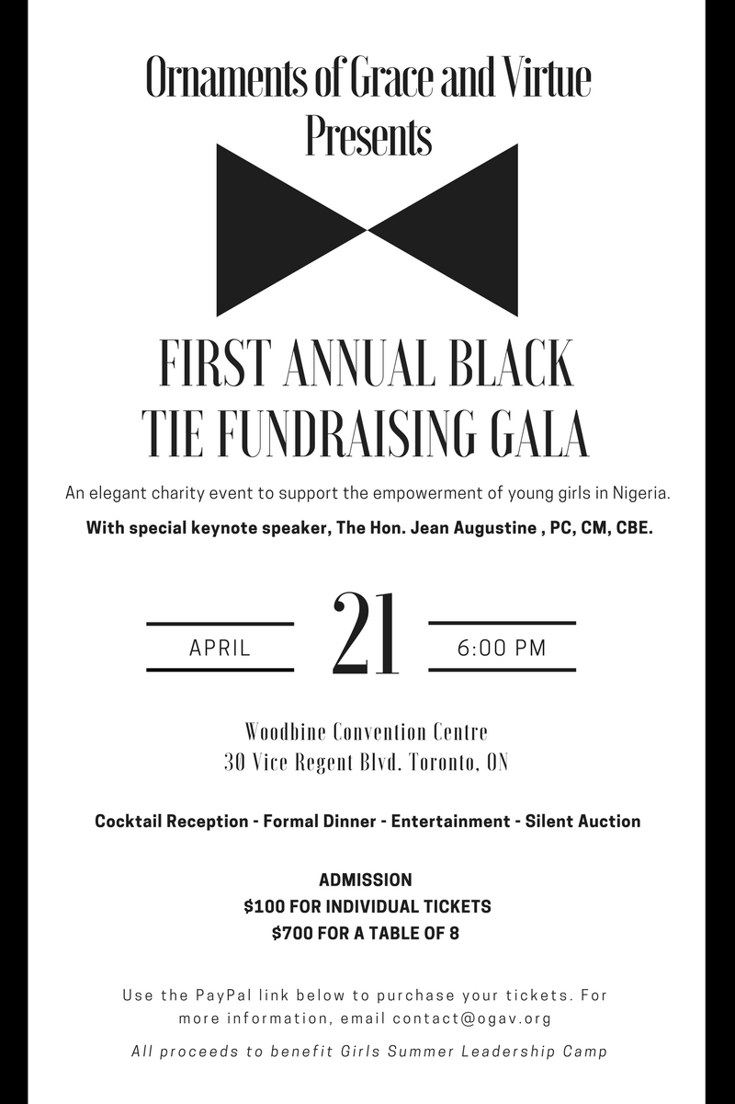

Ticket Options


Ticket Options

2018 Black Tie Fundraising Gala
OGAV requests the honour of your presence to it’s Second Annual Black Tie Fundraising Gala
Saturday April 28, 2018
6:00pm-11:30pm
Woodbine Convention Centre
30 Vice Regent Blvd,
Toronto, ON
Contact Info:
contact@ogav.org
CLICK HERE FOR TICKETS

FUNDRAISER

